Notification.java — Produc
public interface Notification {
void send(String message);
String getChannel();
}

EmailNotification.java · SMSNotification.java · PushNotification.java — ConcreteProduct
public class EmailNotification implements Notification {
private final String email;

public EmailNotification(String email) { this.email = email; }

@Override
public void send(String message) {
System.out.println("[EMAIL → " + email + "] " + message);
}

@Override
public String getChannel() { return "Email"; }
}

public class SMSNotification implements Notification {
private final String phone;

public SMSNotification(String phone) { this.phone = phone; }

@Override
public void send(String message) {
System.out.println("[SMS → " + phone + "] " + message);
}

@Override
public String getChannel() { return "SMS"; }
}

public class PushNotification implements Notification {
private final String deviceId;

public PushNotification(String deviceId) { this.deviceId = deviceId; }

@Override
public void send(String message) {
System.out.println("[PUSH → device:" + deviceId + "] " + message);
}

@Override
public String getChannel() { return "Push"; }
}
NotificationFactory.java — Abstract Creator (with template method)
public abstract class NotificationFactory {

public abstract Notification createNotification();

public void notify(String message) {
Notification notification = createNotification();
System.out.println("Sending via " + notification.getChannel() + "...");
notification.send(message);
}
}
EmailFactory.java · SMSFactory.java · PushFactory.java — ConcreteCreator
public class EmailFactory extends NotificationFactory {
private final String email;
public EmailFactory(String email) { this.email = email; }

@Override
public Notification createNotification() {
return new EmailNotification(email);
}
}

public class SMSFactory extends NotificationFactory {
private final String phone;
public SMSFactory(String phone) { this.phone = phone; }

@Override
public Notification createNotification() {
return new SMSNotification(phone);
}
}

public class PushFactory extends NotificationFactory {
private final String deviceId;
public PushFactory(String deviceId) { this.deviceId = deviceId; }

@Override
public Notification createNotification() {
return new PushNotification(deviceId);
}
}
Main.java
public class Main {
public static void main(String[] args) {
NotificationFactory factory;

factory = new EmailFactory("alice@example.com");
factory.notify("Your order has been placed!");

factory = new SMSFactory("+84901234567");
factory.notify("OTP: 482910");

factory = new PushFactory("device-abc-123");
factory.notify("You have a new message");
}
}

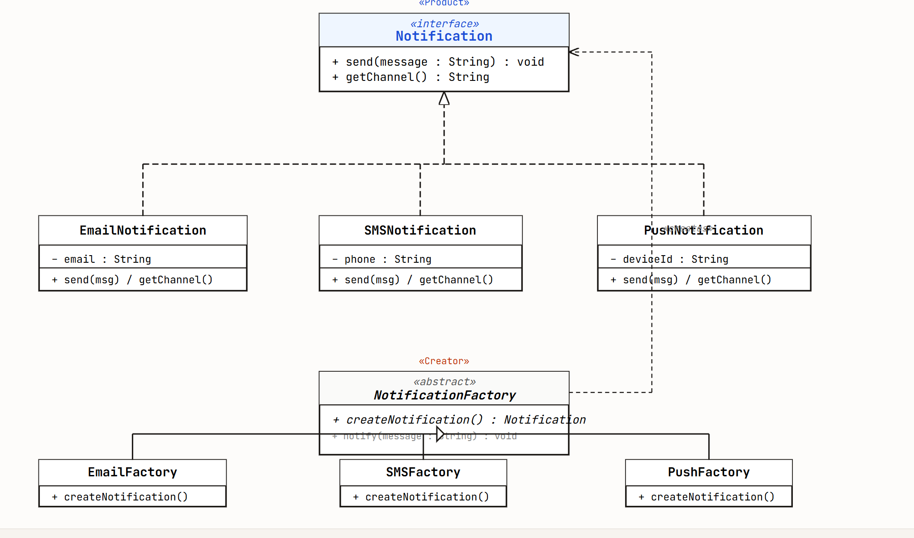

1. Code Java
public class Pizza {
// 1. Các thuộc tính BẮT BUỘC
private String size;
private String crust;

// 2. Các thuộc tính TÙY CHỌN (Optional)
private boolean addCheese;
private boolean addPepperoni;
private boolean addMushroom;

// 3. Constructor (Nên để private để bắt buộc phải dùng qua Builder)
private Pizza(PizzaBuilder builder) {
this.size = builder.size;
this.crust = builder.crust;
this.addCheese = builder.addCheese;
this.addPepperoni = builder.addPepperoni;
this.addMushroom = builder.addMushroom;
}

// Hàm in thông tin để test
@Override
public String toString() {
return "Pizza [Size=" + size + ", Crust=" + crust +
", Cheese=" + addCheese + ", Pepperoni=" + addPepperoni +
", Mushroom=" + addMushroom + "]";
}

// ==========================================
// 4. STATIC INNER BUILDER CLASS (Trọng tâm đề thi)
// ==========================================
public static class PizzaBuilder {

private String size;
private String crust;
private boolean addCheese = false; // Mặc định ban đầu là không có
private boolean addPepperoni = false;
private boolean addMushroom = false;

\\Tham số nào BẮT BUỘC thì nhét vào Constructor của Builder
public PizzaBuilder(String size, String crust) {
this.size = size;
this.crust = crust;
}

// Các hàm set cho thuộc tính TÙY CHỌN
public PizzaBuilder withCheese() {
this.addCheese = true;
return this;
}

public PizzaBuilder withPepperoni() {
this.addPepperoni = true;
return this;
}

public PizzaBuilder withMushroom() {
this.addMushroom = true;
return this;
}
// Hàm chốt đơn đúc ra Pizza
public Pizza build() {
return new Pizza(this);
}
}
}
2. Hàm Main để chạy test (Demonstration)
Java
public class Main {
public static void main(String[] args) {

// Khách 1: Chỉ gọi Pizza cơ bản, không lấy thêm Topping gì hết
Pizza basicPizza = new Pizza.PizzaBuilder("Nhỏ", "Đế mỏng").build();
System.out.println("Khách 1: " + basicPizza.toString());

// Khách 2: Thích ăn phô mai ngập ngụa và xúc xích
Pizza meatLoverPizza = new Pizza.PizzaBuilder("Lớn", "Đế dày")
.withCheese()
.withPepperoni()
.build();
System.out.println("Khách 2: " + meatLoverPizza.toString());

// Khách 3: Lấy full topping (Gõ liên hoàn method chaining)
Pizza fullPizza = new Pizza.PizzaBuilder("Vừa", "Đế viền phô mai")
.withCheese()
.withPepperoni()
.withMushroom()
.build();
System.out.println("Khách 3: " + fullPizza.toString());
}
}

hashMap
public double getSubTotal(){
double subTotal =0.0;
for (Map.Entry<MenuItem, Integer> entry : items.entrySet()) {
MenuItem item = entry.getKey();
int quantity = entry.getValue();

subTotal += (item.getPrice() * quantity);
}
return subTotal;
}

- Singleton Pattern

Objective:
- Implement a Singleton class to ensure only one instance of a resource exists.

Task:
- Create a Logger class:
  - Ensure it has a private constructor.
  - Use a static method getInstance() to return the single instance.
  - Add a method log(String message) to print messages with timestamps.
- Write a main program:
  - Retrieve the Logger instance multiple times and log different messages.
  - Verify that all messages are logged using the same instance.

Expected Output:
- Logs should show timestamps and be consistent across the application, ensuring one instance of Logger.
Hint: the log method could be:
// Method to log messages with a timestamp
public void log(String message) {
String timestamp = LocalDateTime.now().format(DateTimeFormatter.ofPattern("yyyy-MM-dd HH:mm:ss"));
System.out.println("[" + timestamp + "] " + message);
}

Logger
package problem1;

import java.time.LocalDateTime;
import java.time.format.DateTimeFormatter;

public class Logger {

private static Logger instance;

private Logger() {}

public static synchronized Logger getInstance() {
if (instance == null) {
instance = new Logger();
}
return instance;
}

public void log(String message) {
String timestamp = LocalDateTime.now()
.format(DateTimeFormatter.ofPattern("yyyy-MM-dd HH:mm:ss"));
System.out.println("[" + timestamp + "] " + message);
}
}

SingletonPattern
package problem1;

import java.time.LocalDateTime;
import java.time.format.DateTimeFormatter;
import java.time.format.FormatStyle;

public class SingletonPattern {
private static SingletonPattern instance;

private SingletonPattern() {

}

public static SingletonPattern getInstance() {
if (instance == null) {
instance = new SingletonPattern();
}
return instance;
}

public void log(String message) {
String timeStamp = LocalDateTime.now().format(DateTimeFormatter.ofLocalizedDateTime(FormatStyle.MEDIUM));
System.out.println("[" + timeStamp + "]. " + message);
}
}

Main
package problem1;

public class Main {

public static void main(String[] args) {
Logger logger1 = Logger.getInstance();
logger1.log("Application started.");

Logger logger2 = Logger.getInstance();
logger2.log("User logged in.");

Logger logger3 = Logger.getInstance();
logger3.log("Processing request.");

System.out.println("Same instance: " + (logger1 == logger2 && logger2 == logger3));
}
}

